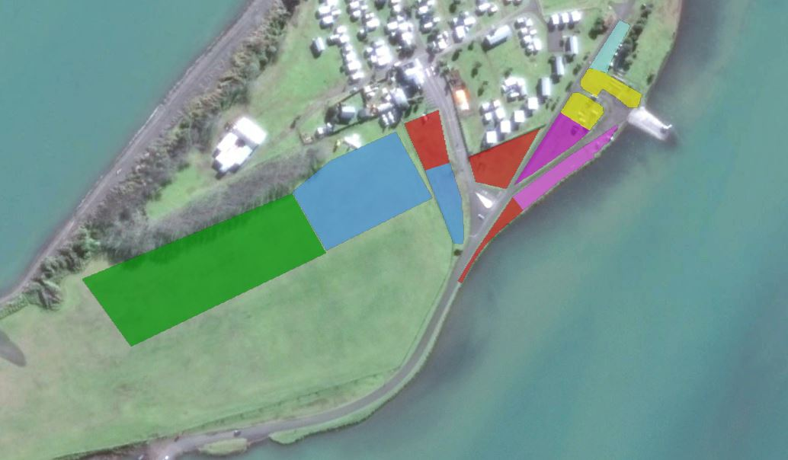
No Parking
Paddler Parking
ReservedParking
Waka Trailer Parking
Admin Areas
Waka Rigging ONLY
NO PARKING
Waka Rigging ONLY
NO TRAILERS
Admin Areas
Waka Trailer
Parking
Reserved Parking
Paddler Parking
Public Toilets

Hot Showers

